SUPERVISION
Date / time: 13/11/2025

Main issues discussed
1. The main problem with my writing: the text is too dense and compact.
2. Any specialised methodological concept must be clearly defined and illustrated with examples.
3. The presentation should not try to cover too much. It should be shortened to fit within 10 minutes and must cover the research question, why it is interesting or important, the research contribution, the process, and the results.
4. Master’s defence questions are usually at a medium or relatively high level, rather than focusing on extreme details. For example, they may ask why a particular model was chosen and how it works. They may also ask about the project’s contribution, findings, and what type of machine learning problem it belongs to.
4. Project adjustments are a way to show independence; if there are none, it is fine not to write anything.

Work shown
- Show my supervisor two draft versions of the RealWorld dataset preprocessing.
My supervisor’s suggestion: write more, explain why it is necessary, and give some examples.
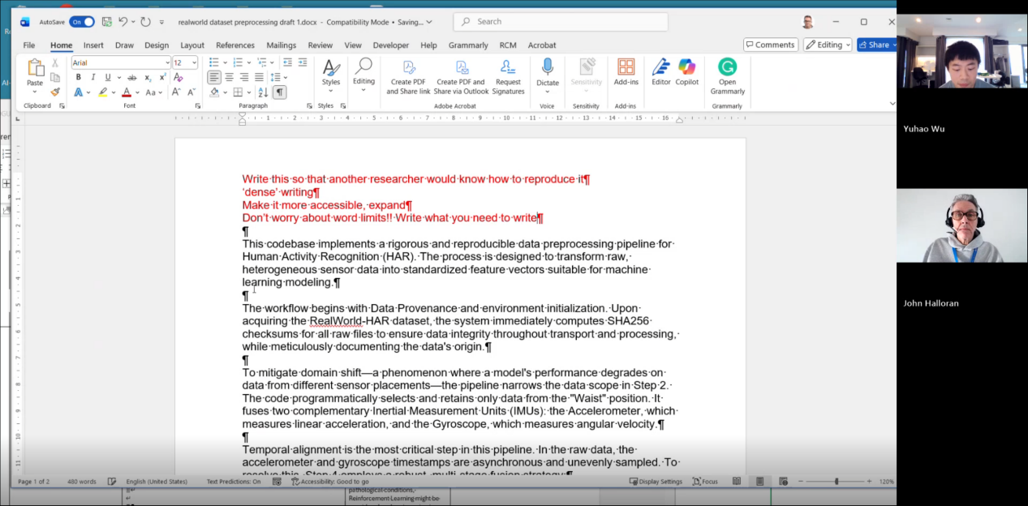

- Experiments presented: I added two state-of-the-art models, DeepConvContext and rTsfNet, as my model baselines. Then, by combining the strengths of rTsfNet, DeepConvContext, and Transformers or some other models, I designed two new models.
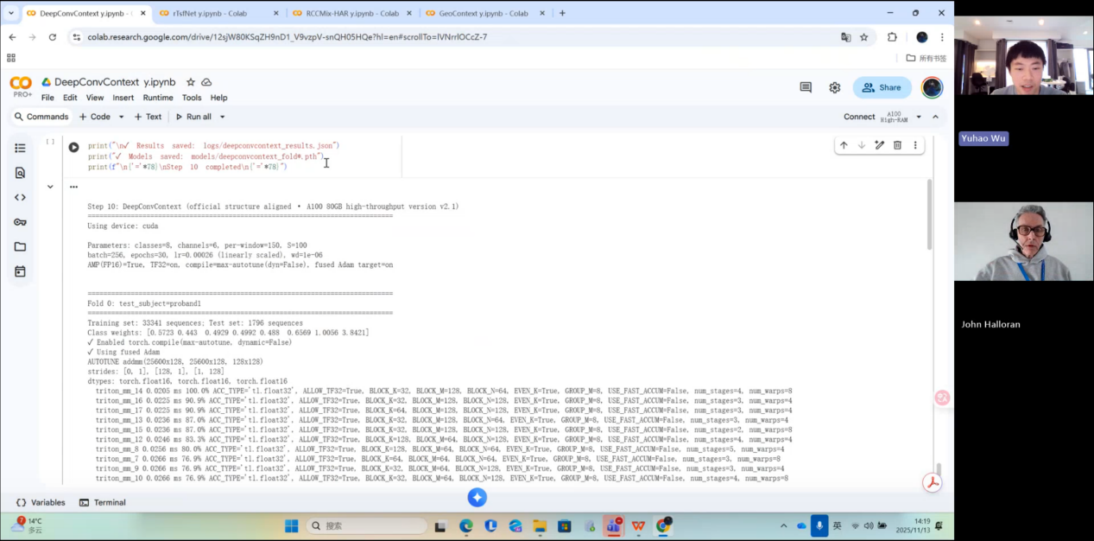

- Show my supervisor my entire experimental workflow.
My supervisor thinks my workload is very heavy and asked whether I am confident I can finish it. My answer was yes.
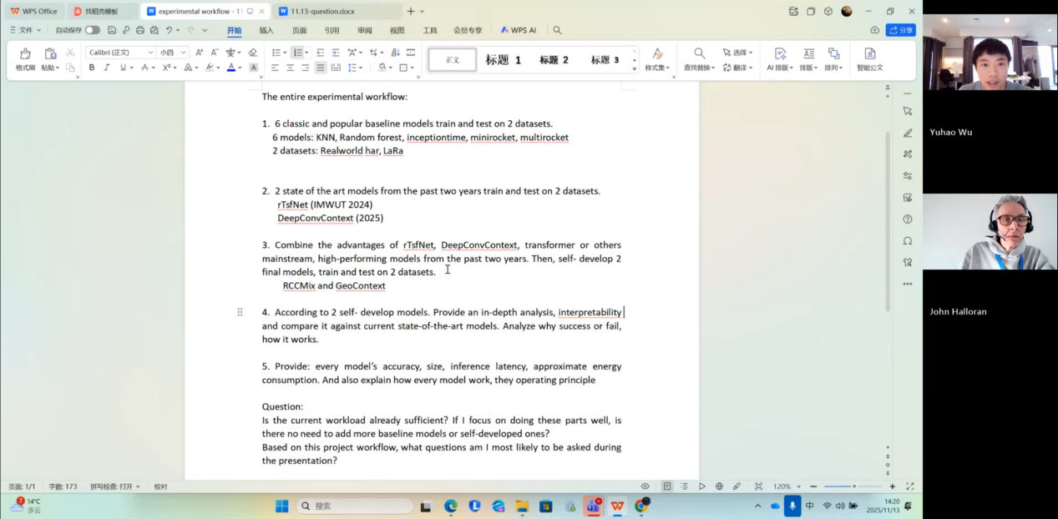

Questions asked; how questions were answered
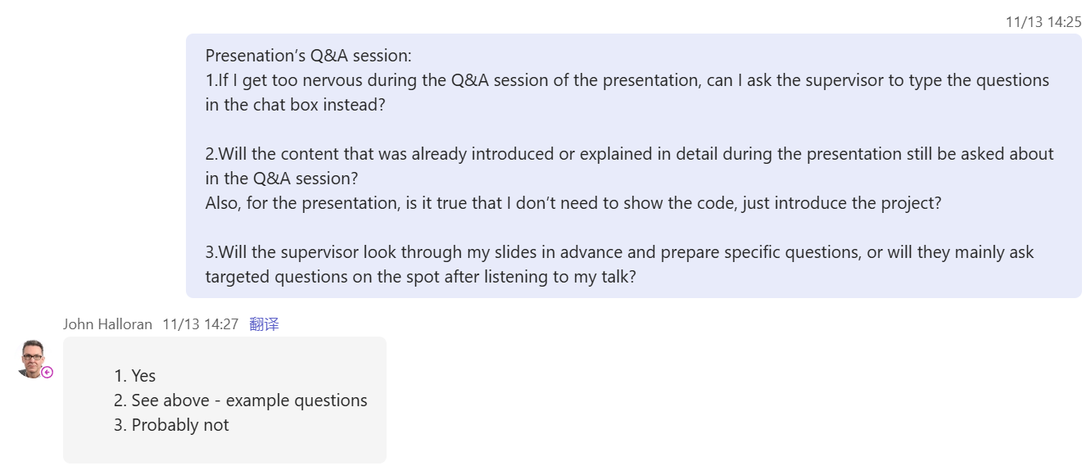

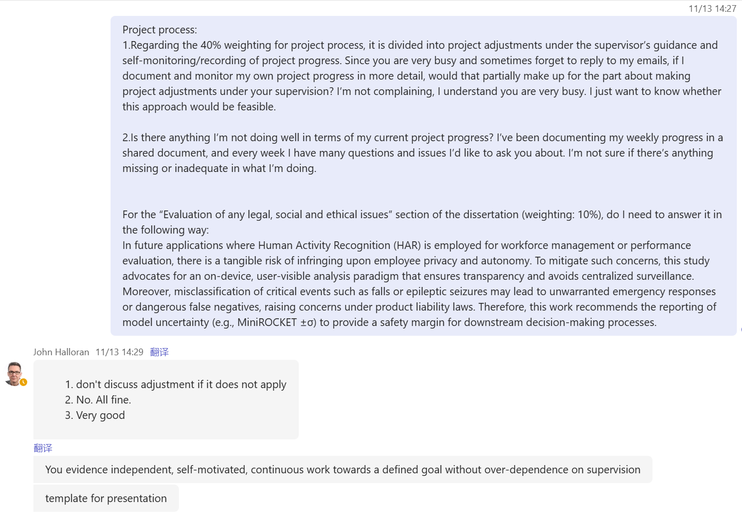

Email
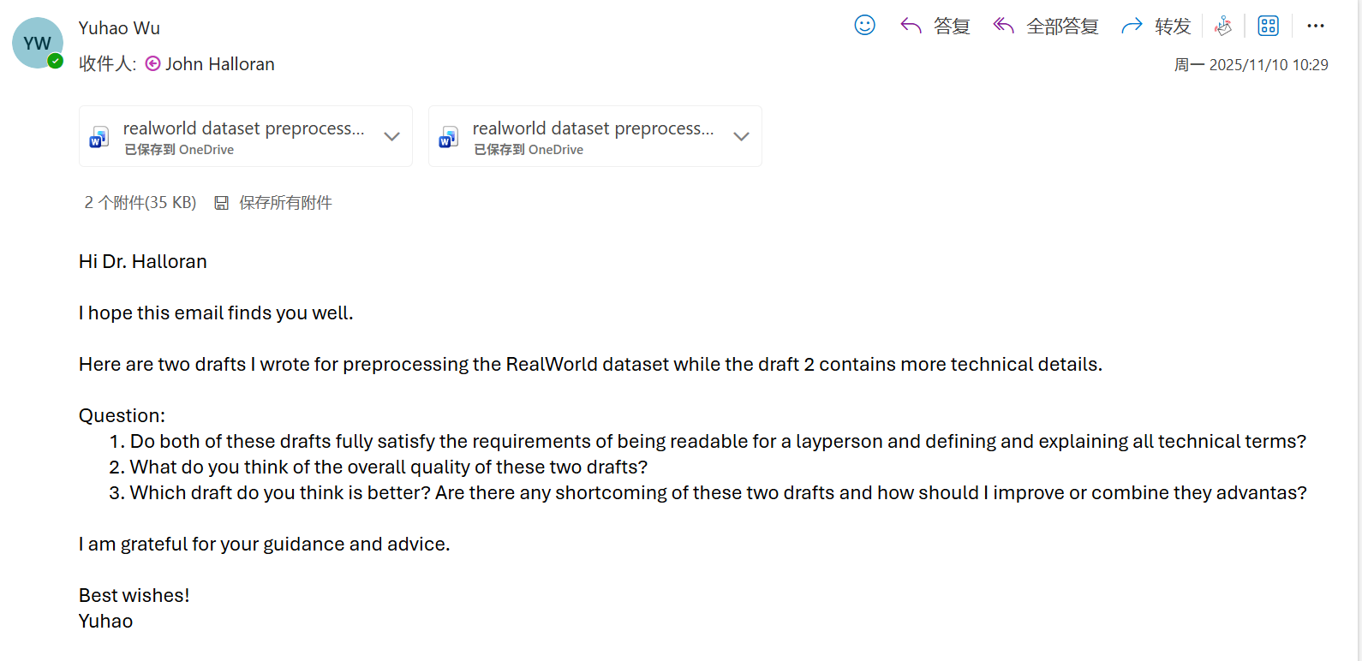
As my supervisor had not replied due to being busy, I presented it to him in this week’s meeting.

Computing Project
WORK DONE
1. I completed the DeepConvContext code and trained and tested it on the RealWorld dataset.
2. I designed a new model, RCCMix Lightweight, and also solved its poor performance problem on the LARa dataset.
3. I have written about half of the literature review, up to Chapter 6 on Evaluation Methodology.
4. I successfully modified the code so that, for the LARa dataset, it now runs through all folds automatically instead of using a single-fold mode.
5. Verified the sensitivity and robustness experiments for MiniRocket.
6. Completed the statistical verification methods, model calibration, and error analysis experiments for half of the models.
7. I have organised part of the project process evidence and created a “project_process” folder in GitHub.

Issues and challenges
- I only used one variant of DeepConvContext, so the evidential strength is insufficient.
- The 4 December submission deadline is very close, but the experiments have not been fully completed or finalised. The code and project process also still need to be organised, and time must be reserved for writing the dissertation and preparing the presentation.

Actions for next week
- Organise the code and upload it to GitHub
- In-depth analysis of RCCMix
- Inference latency code
- Model size code
- Organise the project progress
- Measure the remaining model’s size, inference latency, and energy consumption

Link to recording
Part 1
https://livecoventryac-my.sharepoint.com/:v:/g/personal/wuy176_uni_coventry_ac_uk/IQCjpKhjMuW8QrGNSGusEJ7JAbOPU20GFg2jTZTlCPeg0J4?nav=eyJyZWZlcnJhbEluZm8iOnsicmVmZXJyYWxBcHAiOiJTdHJlYW1XZWJBcHAiLCJyZWZlcnJhbFZpZXciOiJTaGFyZURpYWxvZy1MaW5rIiwicmVmZXJyYWxBcHBQbGF0Zm9ybSI6IldlYiIsInJlZmVycmFsTW9kZSI6InZpZXcifX0%3D&e=wCjgwK

Part 2
https://livecoventryac-my.sharepoint.com/:v:/g/personal/wuy176_uni_coventry_ac_uk/IQBYQUDFbcoySZkdRDfmjmsRAT1zmEghJL1-QdOwxQPFb5o?nav=eyJyZWZlcnJhbEluZm8iOnsicmVmZXJyYWxBcHAiOiJTdHJlYW1XZWJBcHAiLCJyZWZlcnJhbFZpZXciOiJTaGFyZURpYWxvZy1MaW5rIiwicmVmZXJyYWxBcHBQbGF0Zm9ybSI6IldlYiIsInJlZmVycmFsTW9kZSI6InZpZXcifX0%3D&e=P7sb2C

